NOTES ON SESSION 1 OF THE WORKSHOP ‘GRAMMAR WITH EASE’ BY USHA PANDIT
ON 15TH OCTOBER 2022

Why Grammar?
- You cannot learn English through grammar, you can only analyse what you know.
- Grammar must address all parts: labelling, vocabulary, spoken, written to be effective.
- Otherwise, grammar will be like a mechanic knowing the engine of a car who never learnt to drive it.
- If you want to correct writing in children you can use the language of grammar if they also speak it well. Add an adjective before all nouns, an adverb before all verbs. Begin with a participle phrase. Use correlatives and complex sentences.
- Going forward, every competitive exam in the world has a grammar component. This is not to test your labelling skills, it is to eliminate you from the vast sea of applicants by giving you items that will make it possible to glean 300 out of lakhs because there is only one right answer and the question is a super tough one.
- Linear or vertical grammar falls prey to the forgetting cycle. The scope of grammar is very large so sequencing must be correct and horizontal or lateral.

How we all Learn?
A teacher must work smart not hard….
If you are working hard you are doing something wrong.
- Understanding purpose (make sure children know the why of grammar)
- Fun and curiosity element (brief, interactive, oral and dynamic)
- Umbrella view or big picture (whole language learning)
- Layering (frequency and feather duster)
- Scaling (on a solid foundation)
- Application and real use (expecting grammar and vocabulary in writing)
- Success (impressing everyone with language fluency)
My pedagogical mantra VFC (volume, frequency, context)
Immersion and plenty/brief and often/situational and real

The Grammar Pyramid

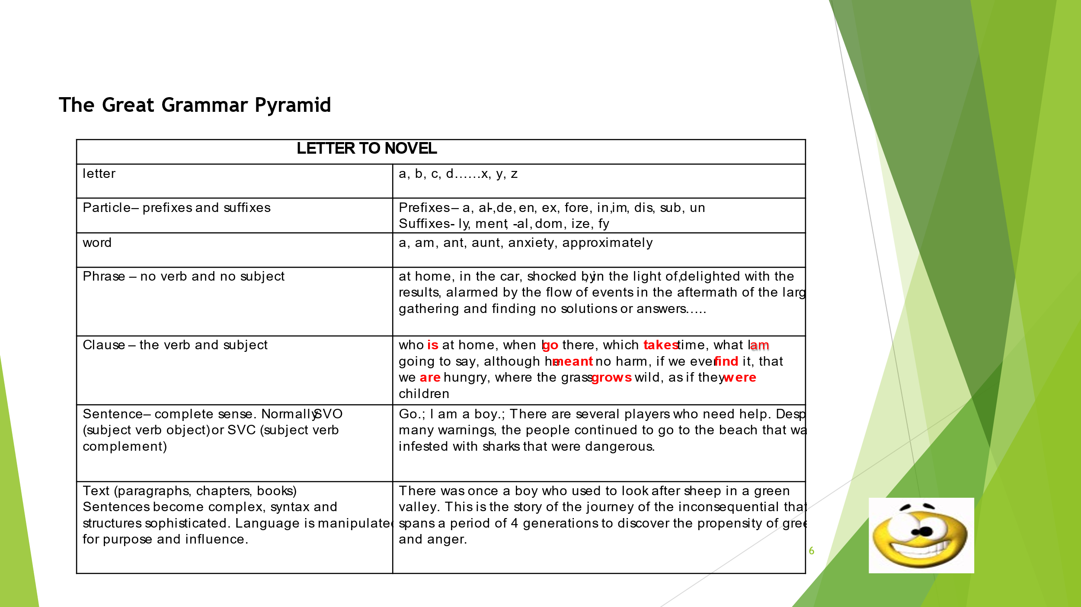
The Parts of Speech Poem
Nouns are names of everything
Rita, Paris, cow or string (ideas, feelings, institutions)
Adjectives describe the noun
Tall, hot, three, cotton and brown (my, this, some,which)
In place of nouns, the pronouns stand
‘He’ for Ram, ‘she’ for Maya, ‘it’ for land (impersonal it and who)
Verbs are actions such as ‘sing’
‘Is reading’, ‘has come’, ‘took’, ‘will bring’ (passive, Phrasal verbs, non-finites)
Adverbs more of verbs do tell
Slowly, quickly, fast or well ( ‘up’ and ‘down’, ‘very’, unbelievably)
Conjunctions join words together
This or that, rich but humble, mother and father (for, if, neither nor, although)
Prepositions show time and position
‘At’, ‘from’, ‘to’, or ‘near’ the station (to school; to eat)
With Interjections you exclaim
Alas! Ugh! Eeks! Wow! What a game! (Go! Wow! The same?)
Functionality of Parts of Speech
- FUNCTION IS ALL!
- Words have not significance except for the work they do in a sentence.
- The word is not automatically a part of speech, the function makes it so.
- E.g. The word “light” works in different ways
- “The light was poor” is a noun
- “the light colour suits you” is adjective
- “I am going light with my lunch” is an adverb
- “I light the lamps daily.” is a verb
Here are words to label and then change to other parts of speech
- Smart, lead, pants, spelt, last, left, work, rest, might,

Eight Parts of Speech
- Nouns
- Pronouns
- Adjectives
- Verbs
- Adverbs
- Prepositions
- Conjunctions
- Exclamations

Nouns (naming words)
Play name place animal thing.
- Names of people, places, creatures, things, qualities, feelings, big ideas
E.g. Rita, Paris, horse, table, kindness, anger, truth, democracy
- Nouns answer the question ‘who’ or ‘what’ put to a verb.
E.g. Sita runs. Who runs? Table breaks. What breaks?
- A noun often ends in:
– ist, -ism, -ity, -y, -ion, -ness, -ment, - ance, -ship, -ice, -ace, - hood, -dom, -cy

- Put an article (a/an/the) or a pronoun like ‘my/is/its’ before the word and see
if it makes sense.
Example:
The population/security/enchantment/ boldness/ lethargy/ likelihood
My simplicity/fortune/ independence/ stupidity
Throw random nouns at kids and get them to USE the tip

Pronouns (stand in place of nouns)
Pronouns stand in place of nouns.
They can be replaced by nouns.
They do everything that nouns do.
A pronoun cannot be followed by a noun. This is mine.
If it has a noun after it, it is an adjective. This is my bag.
Singular: I, you, he/she/ it.
Plural: We/you/they
E.g. She = Ratna. It = chair. They = the student
Do conjugations through drills.
Pronouns also do the following: Get kids to understand meanings of terms
If it has a noun after it, it is an adjective (same labels)
Demonstrative: this, these, that, those
Show indefinite: some, all, several
Relative: who, which, that, whose
Distributive: each, either, neither
Interrogative: whom, what, which
Comparative: better, longer, smarter
Possessive: mine, yours, his, hers, its, ours, yours, theirs.
Emphatic/Reflexive myself, yourself, herself, himself, itself, ourselves, yourselves, themselves.

Adjectives (describe Nouns)
Adjectives are describing words to tell us more about nouns.
Adjectives usually end in –ual, -ic, -ing, -ous, -al, -ive, -ine, -ant, -ent, -full, -ish, -ble, -ial, -less, -ar.
Adjectives are always connected to nouns.
Can you tell the difference?
- Some words function as pronouns and adjectives
- Some may function only as pronouns.
- Adjective types have the same labels as pronouns: distributive, interrogative, comparative, possessive, demonstrative, indefinite, relative. (except reflexive/emphatic)
- Adjectives describe the number, colour, size, texture, quality, quantity and characteristics.
E.g. two, red, big, silky, strong, some, stubborn
Order Acronym: DOSASCOMP (determiner, opinion, size, age, shape, colour, origin, material and purpose) +noun
( The wonderful large ancient oblong brown Chinese wooden writing table.)
Use each of these and describe these nouns:
Table, happiness, poverty, mountain, sand, situation, labourer, Intensity, height, beauty, elf.

How to identify Adjectives
- Adjectives are always connected to nouns.
- Put a simple noun after the adjective - as in ‘man’ or ‘city’ or ‘cake’ or ‘feeling’
- e.g. dangerous/unexpected/incredible/ horrible/ immediate/ bold/ fortunate/ populated/magnificent/ delicious/ unbearable/ hopeful/ striking / loving
- Adjectives answer the question ‘what kind?’ or ‘which?’ put to the noun.
- Examples: Pretty girl, girl is tired, flowering tree, house in a terrible condition.
- Adjectives come before the noun (attributive) or after the noun (predicative)
- The horrible nightmare. The nightmare was horrible.
- Adjectives can be –ing words (with no helpers) like
- Piercing scream, laughing children, chirping birds.
- The screams were piercing. The children were laughing. The birds were chirping.
- The predicative adjectives look like verbs ‘were laughing’ but are not.

Adjective Games
- Ban the trite adjectives from the classroom: bad sad nice etc.
- Provide lists of adjectives and get them to categorize into positive and negative and neutral. Use these to describe a person. Link to Literature study.
- Play I spy detective games for guess who?
- Let’s find all the silly, monstrous, disgusting adjectives
- Create a target to insult!!! Ban: classmate subjects.
- Teach how bad language is not as effective.
- Adjective making competition with DOSASCOMP
- Determiner, opinion, size, age, shape, colour, origin, material, purpose.
“Several magnificent tall, brown trees with long young green leaves.”
Link this to word pictures … imagery… illustrate to find out.
Caution: too many adjectives can weigh down a sentence. So keep quality in mind.

Verbs (words of doing, being, having)
- Verbs are action words that function to:
1) show action: jump, sing, eat, dance, talk
2) show status: am, is, are, were
3) show possession: has, had, own, belong
4) show passive subject: The rat was killed by the cat
- Simple verbs have one word – go, goes, went
- Compound verbs have more than one word –
am going, will take, should have come, may have been taken
There are 3 primary verbs: to do, to have, to be.

Auxiliary verbs are helping verbs. Do and have hold the past tense. didn’t know, had come
If there is no auxiliary verb before an –ing word, it is not a verb.
Imposter verbs - -ing words without helpers, to + base verb.
Phrasal verbs: run into, run up, run down, run against, run over, run out of etc.
Irregular verbs E.g. To Run – ran – had run; to cut – cut – had cut
to take – took – had taken; to learn – learnt – had learnt
(Tip: Make their past participle form had + past participle to get the right past participle.)
- Verbs endings: typically end in –ate, -ise, -ify or –ize

Subject and Predicate. Modals. Conditionals.
- Don’t over-teach with definitions, notes and limited exercises.
- Don’t offer small children complicated sentences where there are complexities.
Subject Predicate. All sentences have a verb. Heart of the sentence. The verb has a doer – the subject. The verb + all that is after it gives information about the subject. This is called predicate. The girl fed the little cat a bowl of milk.
Modal verbs: can, could, will, would, shall, should, may, might, must, ought.
These cannot be conjugated. They are both helpers and main verbs.
Conditionals:
- 0 conditional (scientific facts) If water boils, it evaporates (present- present )
- 1st conditional (certain future) If it rains, I will get wet. (present – future)
- 2nd conditional (imaginary) If he won the lottery, he would buy a car (past + conditional would)
- 3rd conditional (unreal) If he had won the lottery he would have bought (past perfect + would have + past participle)
Use these conditional in imaginary compositions and fantasy writing. Play games.
16 Tenses of Verbs
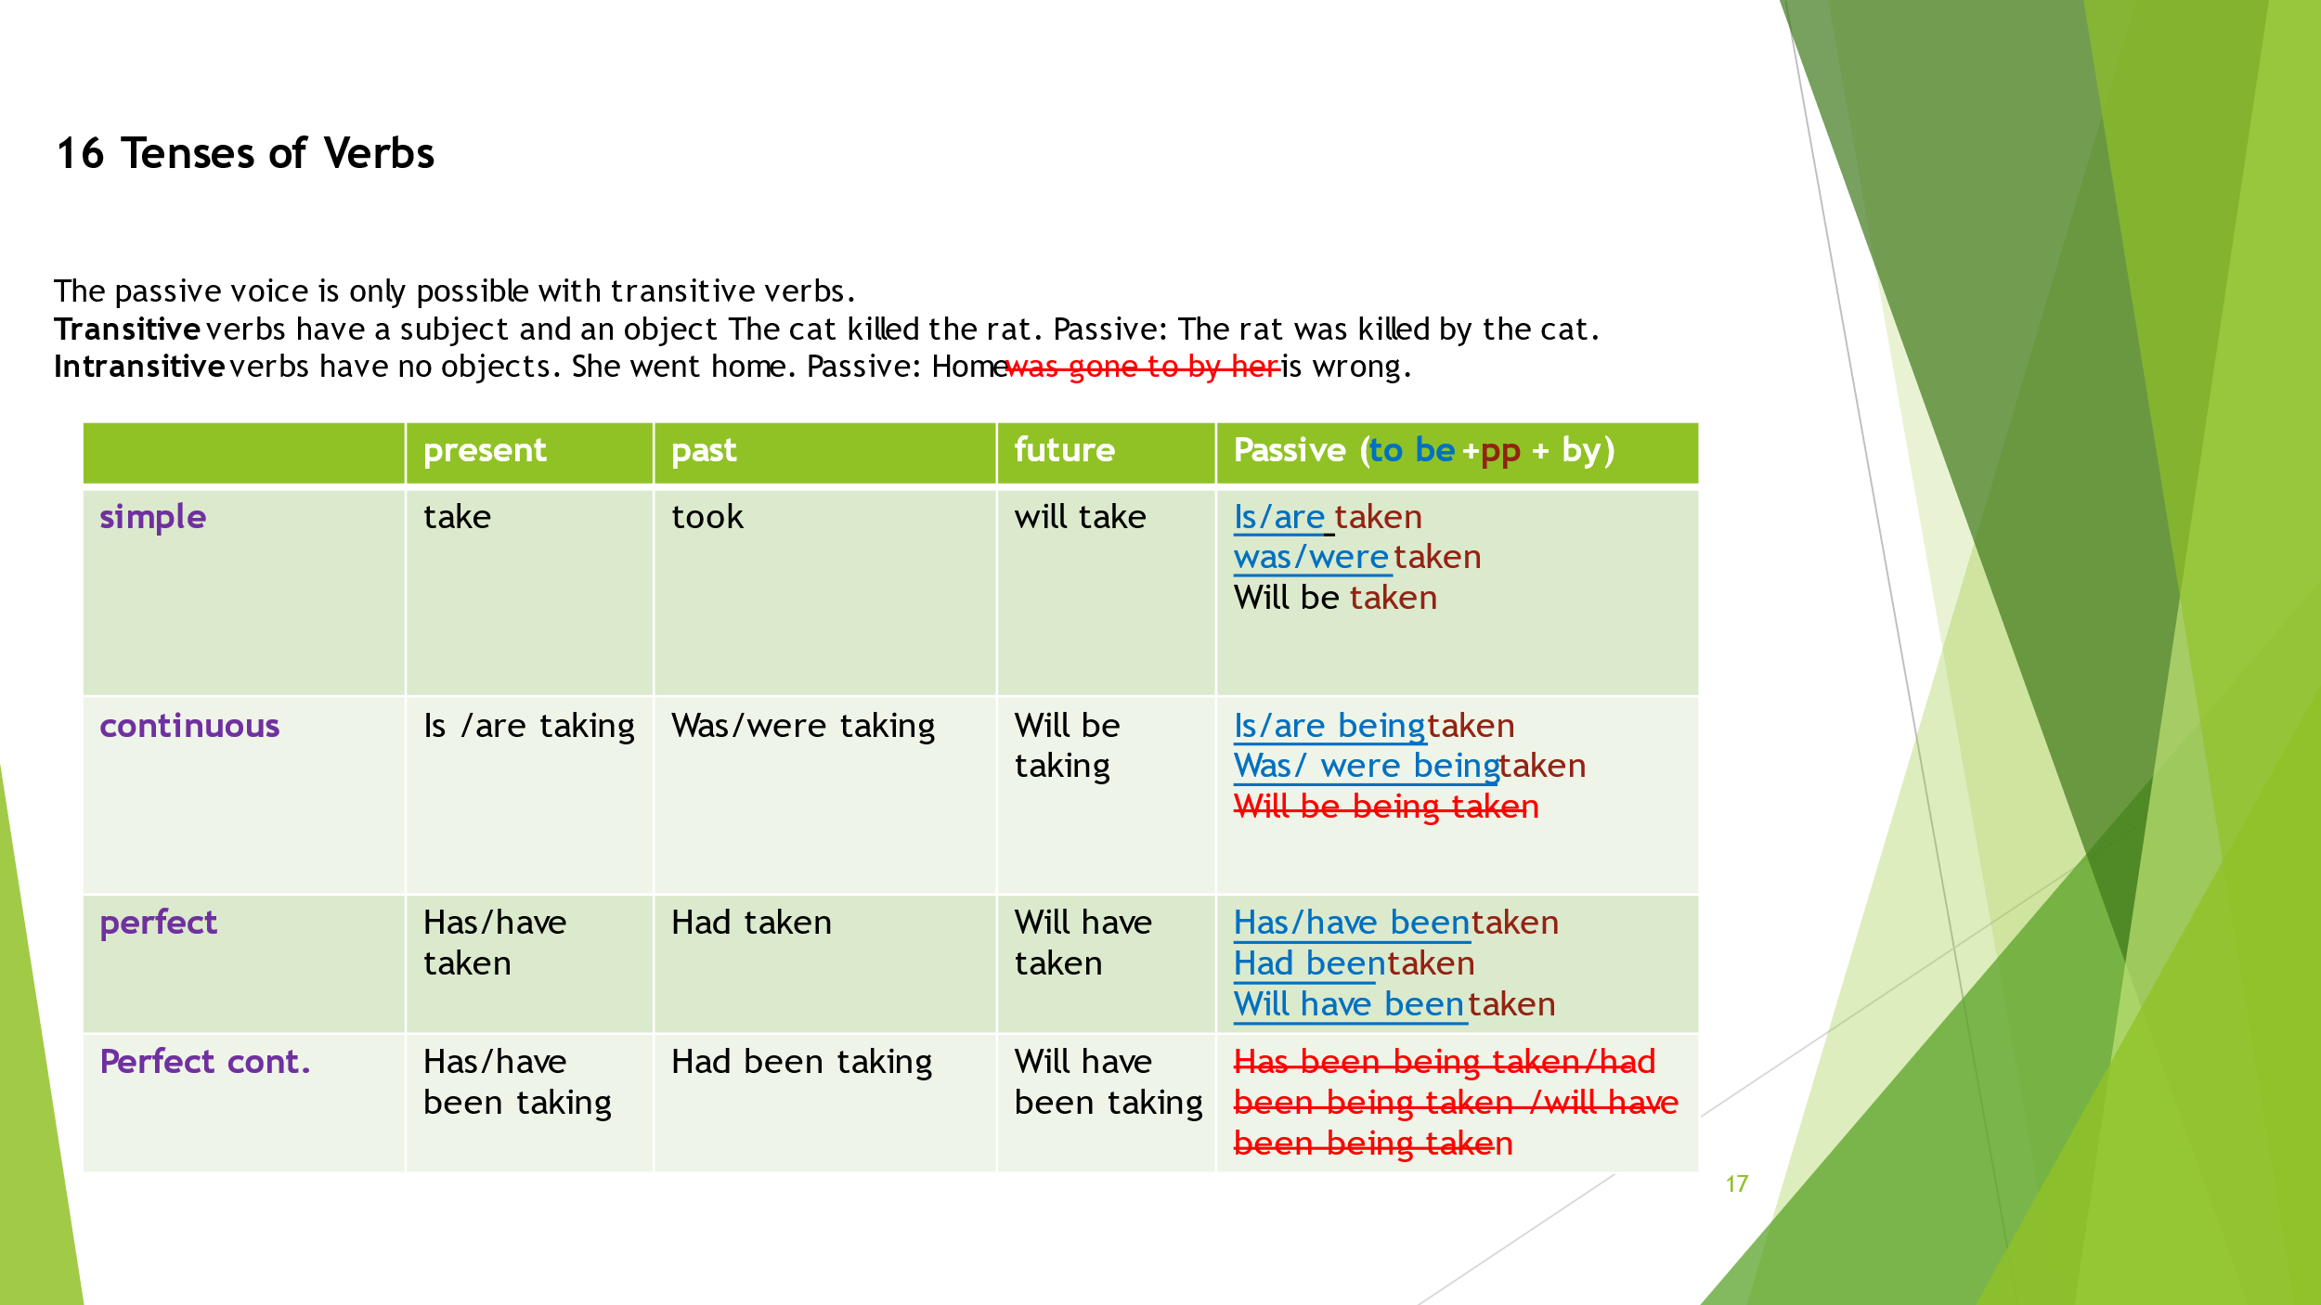

The uses of Tenses
Habit/truth = present simple (He drinks tea/ the sun rises in the east)
Happening now = present continuous (I am speaking to you )
Experience = present perfect (I have travelled to France often)
Plan = future (I will go to the temple tomorrow)
Yesterday = past simple (I took my mom to the doctor)
Happening for a while = present perfect continuous
( I have been playing the piano for 5 years
Two actions in the past =
past / past perfect (He had left by the time I got home)
past / past continuous = ( when I got home mother was cooking lunch)
past / past perfect continuous = (when I got home mother had been cooking )
Verb games and Exercises
- Run-stop-act. You can teach even pre primary a large number of verbs by playing this game. When teacher says stop she gives them a verb e.g. stomp. She stomps around and they learn stomp. You can do any action verb with this like stagger, yell, gallop, dashed, snatched, stooped, squirmed, stammered, smirked etc. Lots of fun
- Play charades. One child does an action and the other names it.
- Picture talk with modals. Give a set of pictures and tell kids to make sentences using only modal verbs.
- Chunnilal stories: Give kids slips with these stories to read and change to present tense. (I go to the shop and buy….) or Use ‘I’ instead of Chunnilal.
“ Yesterday, Chunnilal went to the shop and bought some chips to eat. When Chunnilal reached home he found a cockroach in the bag. So, Chunnilal went back to the shop and returned it. The shopkeeper gave him a new bag of chips but Chunnilal refused it. The shopkeeper gave him back his money.”
- What’s the question?
Ask questions using primary verbs and modals to get these answers.
- I’m sorry I can’t make it.
- Yes, certainly.
- Because she missed the bus to school.
- He escaped through a hole in the wall.
- The car behind us suddenly braked.

Teaching tense names and Reported Speech.
Read the name of the tense from the tense.
If the word ‘past’ comes second in the name change it to the word ‘perfect’.
- Continuous: is jumping, will be jumping
- Present continuous (-ing) future continuous.
Perfect:
- has jumped had jumped will have jumped
- present past past past future past
- present perfect past perfect future perfect.
Perfect continuous:
- has been jumping, will have been jumping
- Present past continuous future past continuous
- Present perfect continuous future perfect continuous
You can read the tense in the words of the compound verb
Reported Speech – changes
Use 3 kids in class to do this for a minute daily.
A says something. B tells C what A said.
- Pronoun (I becomes - he/she)
- Tense backshift ( speak/ spoke; will be able/would be able
- Come becomes go; now becomes then
- Place and time expressions change (this/that; here/there, today / that day; yesterday / day before; next day/the following day)

Adverbs (describe verbs, adjectives and other adverbs)
Adverbs tells us more about a verb, an adjective, another adverb.
Example He drove quickly. She is very intelligent. He writes incredibly well.
All answer the question how? Put to the verb, the adjective, the adverb.
In subordinating clauses the adverb clause answers the questions:
when, where, why, how, what degree, on what condition or affirming and negating or comparative put to the verb.
Make sentences beginning with these to see how they are not complete.
Unusual adverbs:
- Ran how? Fast; Ran where? There;
- Ran when? Daily; ran why ? because; ran to what degree? very fast; ran on what condition? if ; ran - affirmation/ negation : certainly fast & not fast; ran in comparison: faster, fastest.
- Adverbs on the move. Adverbs can be moved around a sentence.
Example: Sadly she died. She died sadly. She sadly died.
Prepositions (relationship words)
- Prepositions are words that show the relationship between two nouns in terms of position, direction, and time.

- A preposition is always followed by a noun
- The cat is in/on/ below/ next to/under the box ( position) the cat went from the kitchen to the hall (direction) the cat has been sleeping since 5 (time).
- A group of words that make a preposition is called a prepositional phrase
- e.g. on top of the box/ at the seashore/ in the morning show position, place and time in relation to another subject.
- Prepositional phrases can be connected to a noun making it adjectival or a verb making it adverbial.
- The boy in the striped pyjamas is the thief.
- The boy moved out of the building in a terrible hurry

Conjunctions (joining words)
Simple Conjunctions join words or phrases
Prabha and Radha can look after mother. /in the morning or at night.
Coordinating conjunctions – Join two sentences that are equal.
FANBOYS (for, and, nor, but, or, yet, so)
Ram the rich boy, yet he was not proud./ Ram was a hardworking boy, but Shyam was lazy. /Ram decided to go to the temple, so Sita took Shuba to school.
Correlating conjunction come in pairs
Not only aggressive Ram but also docile Sita argued with the landlord
Neither did the factory workers come to work nor did the supervisors attend office.
Subordinating conjunctions – Join two sentences in which one is dependent on the other.
E.g. ‘...when I went to the market’, ‘....which is near my house’ are not independent. They need the first sentence ‘I bought some eggs’ & ‘I went to the market’ respectively.
So the conjunctions when, where, because, therefore, although etc. become subordinating conjunctions.
Interjections (exclaiming words)
- Interjections are just single words that show surprise or shock.
- It is the equivalent of emotions in writing.
- Ends with an exclamation mark.
Wow! Great! Alas! Oh no!
The Phrase
The phrase is a group of words that makes sense.
Phrases do not have a verb or a subject
Cottage
- The cottage.
- The lovely old cottage.
- The lovely old cottage by the bridge.
- The lovely old cottage by the bridge over the river.
- The lovely old cottage by the bridge over the river near the mountains.
- Make your phrase pyramid with: nest, fruit, boat, bottle
Types of Phrases
The group of words can do the work of
- An adjective – large, cavernous and empty
- A noun – a purple big-bellied cow
- A verb – has been chasing
- An adverb – with tremendous speed
- A preposition – in the middle of the night
Noun Phrase. Adjective phrase. Verb phrase. Adverb phrase. Prepositional phrase.
- Nest of Boxes - A prepositional phrase contains a noun phrase which in turn, contains an adjectival phrase
- P N A N P
- The school is near { the ( large, hand-crafted, exquisitely white marble ) statue.}
Prepositional phrases can be Adjectival or adverbial. Can you tell?
He lived in a disgustingly damp and dark building.
He is the manager of the disgustingly damp and dark building.
Get students to make phrases with nouns, adjectives and prepositions
Chair, beautiful, until.
Clauses
- A clause is a group of words with a verb in it.
- A clause may be main. (I went to the market.) 1 verb 1 subject.
- A clause may be coordinating ( I went to the market and I bought some eggs.) 1 = 1
- A clause may be subordinating ( I went to the market which is near my house.) 1 > 1 <
- Clauses are of 3 types – Ask what is the function?
- Noun clause. Adjective clause. Adverb clause.
- I know that you are sick. Know what?
- The house which has a red roof is my house. Which house?
- We went home because we were tired. Went why?
Subject verb Agreement
- Rice and beans ___ my favourite dish
- My aunt or my uncle ___arriving by train today.
- Neither Juan nor Carmen ___ available
- Either Kiana or Casey ___ helping today with stage decorations
- Neither she nor I ___ going to the festival.
- The politician, along with the newsmen, ___ expected shortly.
- Every one of the cakes ___ gone.
- One-third of the city ___ unemployed.
- Some of the pie ___ missing.
- Ten dollars ____a high price to pay.
- None of the sentences ___ punctuated correctly.
- The herd of bison ___ grazing near the lions
Resources to Operate the system
Grammar with Ease’ is a very useful resource and reference book that gives a primary child uncomplicated definitions, simple examples and just enough to understand concepts.
Great for beginners.
‘Language with Ease’ is the series from Grades 1 – 7 that you need to teach the pathbreaking system in schools or homes.
‘Writing with Ease’ is a writing resource that has several bits of grammar and vocabulary.
150 videos have been put up on our YouTube channel ‘The Mindsprings English Teacher’ on grammar, writing, and vocabulary. Please subscribe and join the family of 75K subscribers.

